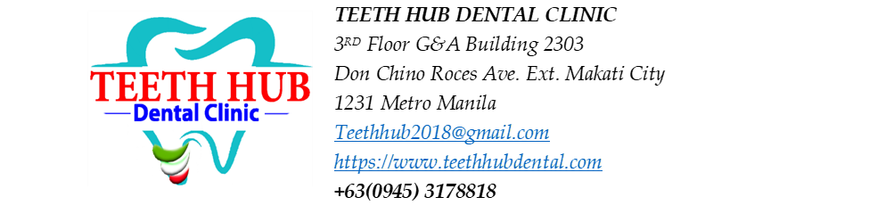
Patient Name: Bai Pacusum

Non-surgical Root Planing (NSRP) Estimated Cost:
NSRP - 5,000 per quadrant x 4 = 20,000
Aqueous Ozone = 1,000

Estimated Treatment Plan
Procedure | Tooth/Area | Estimated Fee
Extraction | #36 | 1,500
Restoration (filling) | #14 - Distal | 1,800
Restoration or Root canal treatment (RCT) | # 12 - Cervical, Mesial (to be assessed for root canal) | 3,600 (Filling) - 8,000 (RCT)
Restoration (filling) | #11 - Cervical, Distal, Mesial | 5,400
Restoration (filling) | #21 - Distal, Mesial | 3,600
Restoration or Root canal treatment (RCT) | #22 - Cervical, Mesial, Distal (to be assessed for root canal) | 5,400 - 8,000 (RCT)
Restoration (filling) | #23 - Mesial | 1,800
Restoration (filling) | #25 - Distal | 1,800
OPTIONAL:
CAOH PASTE -prn- 800/ TOOTH
GI- 1000/ TOOTH

