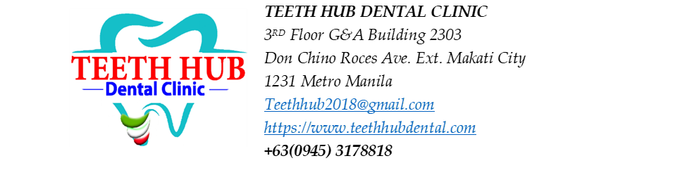
Patient Name: Christelle Lee

Non-surgical Root Planing (NSRP) Estimated Cost:
NSRP - 5,000 per quadrant x 4 = 20,000
Aqueous Ozone = 1,000

Estimated Treatment Plan
Procedure | Tooth/Area | Estimated Fee
Restoration (filling) | #17 - Occlusal | 1,800-2,000
Restoration (filling) | #16 – Occlusal, Lingual | 3,600
Restoration | # 15 – Distal, Occlusal | 3,600
Root canal treatment (RCT) | #14 – with abscess | 8,000/ CANAL
Restoration (filling) | #12 – Mesial, Incisal | 3,600
Root canal treatment (RCT) | #22 - with abscess | 8,000
Restoration (filling) | #23 – Lingual | 1,800
Restoration (filling) | #24 – Distal | 1,800
RCT or Extraction | #25 – with abscess | 8,000/ CANAL
RCT or Extraction | #26 – with abscess | 8,000/ CANAL
Restoration (filling) | #37 – Occlusal, Lingual | 3,600
Restoration (filling) | #33 – Distal | 1,800
Restoration (filling) | #42 – Distal | 1,800
Restoration (filling) | #45 – Occlusal | 1,800
RCT or Extraction | #46 – with abscess | 8,000/ CANAL

NOTE: Root Canal - 8k per canal
OPTIONAL FOR FILLING:
CAOH PASTE -prn- 800/ TOOTH
GI- 1000/ TOOTH

