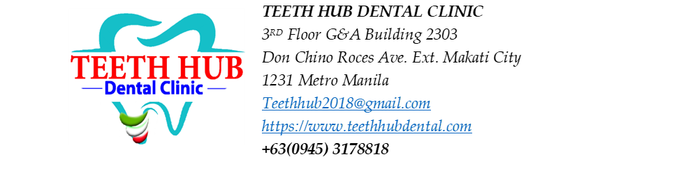
Patient Name: Debbie Cootauco

Non-surgical Root Planing (NSRP) Estimated Cost:
NSRP - 5,000 per quadrant x 4 = 20,000
Aqueous Ozone = 1,000

Estimated Treatment Plan
Procedure | Tooth/Area | Estimated Fee
Restoration (filling) | #17 – Occlusal, Buccal (UPPER RIGHT) | 3,600
Restoration (filling) | #16 – Occlusal (UPPER RIGHT) | 1,800
Restoration (filling) | #12 – Lingual (UPPER RIGHT) | 1,800
Restoration (filling) | #13 – Lingual (UPPER RIGHT) | 1,800
Restoration (filling) | #22 – Lingual (UPPER LEFT) | 1,800
Extraction of primary tooth | #64/65 – root fragment (UPPER LEFT) | 1,500
Restoration (filling) | #26 – Occlusal, Buccal (UPPER LEFT) | 3,600
Restoration (filling) | #27 – Occlusal, Buccal (UPPER LEFT) | 3,600
Restoration (filling) | #38 – Occlusal (LOWER LEFT) | 1,800
Restoration (filling) | #36 – Occlusal, Buccal (LOWER LEFT) | 3,600
Extraction | #44 (LOWER RIGHT) | Starts at 1,500
Restoration (filling) | #46 – Occlusal, Buccal (LOWER RIGHT) | 3,600
Restoration (filling) | #47 – Occlusal (LOWER RIGHT) | 1,800
Restoration (filling) | #48 – Occlusal (LOWER RIGHT) | 1,800

OPTIONAL FOR DEEP CARIES:
CAOH PASTE -prn- 800/ TOOTH
GI- 1000/ TOOTH

Patient Acceptance and Informed Consent
I acknowledge that the proposed treatment, benefits, risks, alternatives, estimated fees, and possible need for additional procedures have been explained to me. I understand that dentistry cannot guarantee specific outcomes. I voluntarily consent to the proposed treatment and agree to the clinic's payment policies.
Patient Signature: __________________ Date: __________

