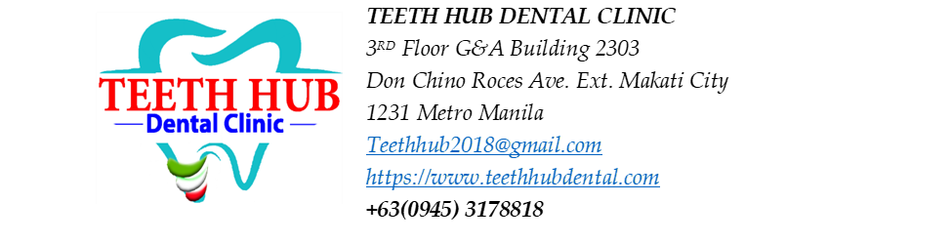

Patient Name: Jamille Diator

Tooth Restoration Estimated Cost

Tooth #38: Occlusal = 1800
Operculectomy = 5000

Tooth #37: Buccal, Occlusal, Lingual - 1800 x 3 = 5400
Possible additional for caoH = (800) | MTA = (1000)

Tooth #36: Occlusal, Lingual - 1800 x 2 = 3600

_____________________
Patient’s Signature

