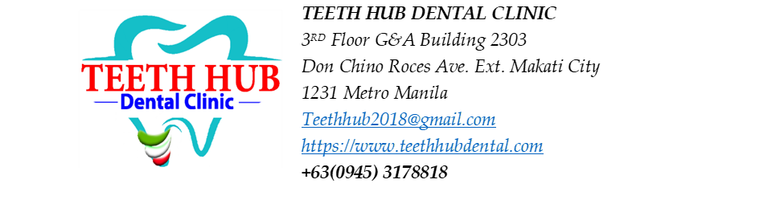
Patient Name: Romela Justo

Non-surgical Root Planing (NSRP) Estimated Cost:
NSRP - 5,000 per quadrant x 4 = 20,000
Aqueous Ozone = 1,000

Estimated Treatment Plan
Procedure | Tooth/Area | Estimated Fee
Extraction | #17 | 1,500
Extraction | #24 | 1,500
Biomimetic or RCT | #12 - mesial, lingual | 9,500 - biomimetic  8,000/canal - RCT
Biomimetic or RCT | #21 – distal | 9,500 - biomimetic  8,000/canal - RCT
Biomimetic or RCT | #22 - mesial, lingual | 9,500 - biomimetic  8,000/canal - RCT
RCT | #35 – lingual | 8,000/canal - RCT
Restoration | #18 – lingual | 1,800
Restoration (filling) | #25 - occlusal, distal | 3, 600
Restoration (filling) | #26 – mesial | 1,800
Restoration (filling) | #27 – mesial | 1,800
Restoration (filling) | #28 – occlusal | 1,800
Restoration (filling) | #38 – occlusal | 1,800
Restoration (filling) | #36 - buccal, occlusal | 3, 600
Restoration (filling) | #34 – occlusal | 1,800
Restoration (filling) | #44 – occlusal | 1,800
Restoration (filling) | #47 – occlusal, buccal | 3, 600
Restoration (filling) | #48 - occlusal | 1,800

NOTE: Root Canal - 8k per canal
OPTIONAL FOR FILLING:
CAOH PASTE -prn- 800/ TOOTH
GI- 1000/ TOOTH

Patient Acceptance and Informed Consent
I acknowledge that the proposed treatment, benefits, risks, alternatives, estimated fees, and possible need for additional procedures have been explained to me. I understand that dentistry cannot guarantee specific outcomes. I voluntarily consent to the proposed treatment and agree to the clinic's payment policies.
Patient Signature: __________________ Date: __________
Parent/Guardian (if applicable): __________________
Dentist Signature: __________________ Date: __________

07/25/26 Procedures done
Oral Prophylaxis – 2,500
Full mouth Periapical Radiograph – 1,000
= 3,500
-300 commitment fee
TOTAL = 3,200

