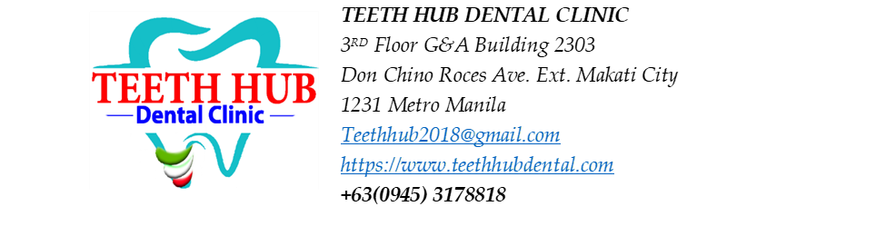
Patient Name: Stephanie Montaya
Date: 08/01/26

Estimated Treatment Plan
Procedure | Tooth/Area | Estimated Fee
Periodontal Gum Mapping Assessment |  | 2,000
Non-surgical Root Planing (NSRP) | 4 quadrants | 5,000 per quadrant x 4 = 20,000
Aqueous Ozone |  | 1,000
Root canal treatment (RCT) | #11 | 8,000 $÷$ 4 = 2,000
Post & Core | #11 | 3,500
Build up | #11 | 8,500

Patient Acceptance and Informed Consent
I acknowledge that the proposed treatment, benefits, risks, alternatives, estimated fees, and possible need for additional procedures have been explained to me. I understand that dentistry cannot guarantee specific outcomes. I voluntarily consent to the proposed treatment and agree to the clinic's payment policies.
Patient Signature: __________________ Date: __________
Parent/Guardian (if applicable): __________________
Dentist Signature: __________________ Date: __________

